Daniel Williamson

Project #7

4/26/17

EE 222

Project Overview

Purpose:

The purpose of this project was to implement merge sort. We randomly generate an unordered list of integers. And then using merge sort we sort the unordered list.

Approach:

To begin, I needed to understand what was required of the project. Merge sort is a complicated sort using recursion. To complete this project, I needed to fully understand it. Essentially, it breaks down an unordered array down to a base case of length 1. Once it hits that, it returns while swapping the left and right positions to merge the arrays together and sort them. I began by randomly generating an array. I needed some numbers to sort. I used the random array generator from last project. Once I had that, I also needed to print out the array to see if it was working. So, I created a helper method to print out a dynamic array sized list. Then I jumped into the merge sort itself. Using recursion and the two methods, mergeSort and mergeSortRecursive, I sort the random unordered array using recursion.

Results:

This is merge sort, sorting 18 numbers:

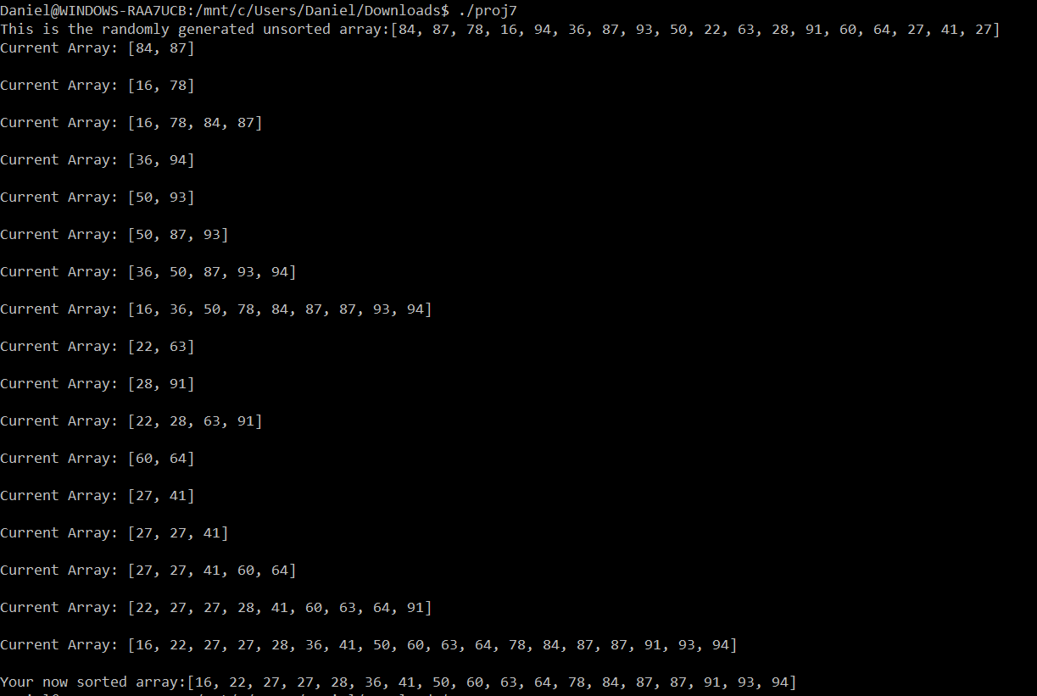

Conclusion:

In conclusion, this was a moderate lab. Since I already had a good understanding of how merge sort works and I already coded it in Java, made this project much easier. The most difficult part was simple just getting the recursion to work the way you wanted it to. To overcome this, I referenced my previous projects and talked with my peers.